Review of Progress as of 29th Nov 2015

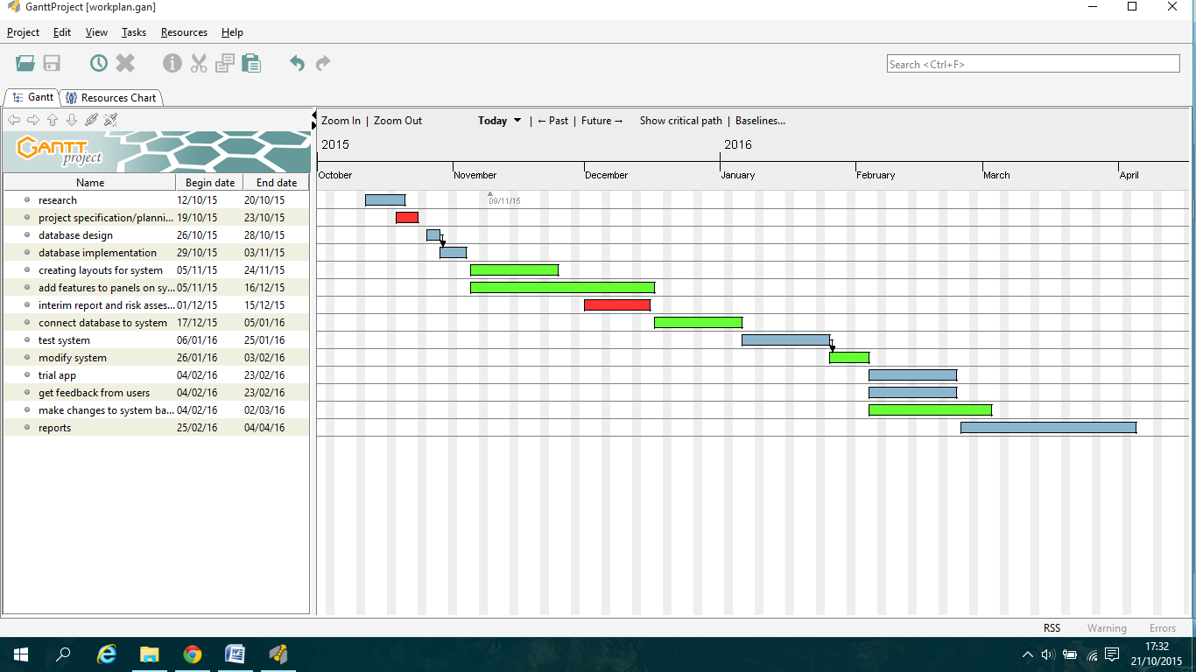This section talks about what I have done as of the 29th Nov 2015 (Beginning of week 10 of semester 1) and I review whether I am on track or not. I will use the work plan below that I created at the start of the project as reference.

**What I have done:**

For this semester I started planning what the app would look like by creating a project specification in which I highlighted the aim of the project and what the requirements would be to make a good app. I created a set of layouts which I want the app to look like and I put these into a storyboard which I explained for each panel what interaction there would be on them allowing me when creating the app to implement it more effectively.

After the planning stages I set up the database using MySQL, I designed the database firstly by hand plotting what tables I would need so far. I have created 5 tables so far:

**login**: this table will be used for handling users creating accounts and retrieving info for logging in.

**quiz**: this handles the individual quizzes which can be created by a user, questions will then be assigned to the quiz they were created for, keeps track of how many questions there are for each quiz and handles the average rating of all the questions assigned to the quiz.

**questions**: this handles specific questions which contain info such as the quiz it is part of, question id, the question and correct answer, usernames of users who created the answers and question.

**question_stats**: assigned to each question to keep track of stats such as how many times the question has been attempted and keeps track of how many times each answer was selected.

**groups:** this handles user created groups by keeping track of what users are in the group ( there are 4 tables for users) and what question they are assigned to. The creator of a question can choose to create the question on their own or as a group where they can then assign members.

I have created 6 php scripts which insert and retrieve data from the tables for displaying leaderboard, displaying what groups user is in, login authentication, registering and authenticating, setting up a new quiz, script to send an email to user if they forgot their login details.

For the App I have created the xml files for the welcome panel(main activity), login panel, registration panel, home panel, leaderboard, create home, create quiz panel, view groups, and create a question panel. I have implemented all of these panels so far except the view groups and I am currently working on the create question panel. I have created multiple classes to store details with shared preferences to use retrieved details on different panels, I have implemented two database classes which connect to the php scripts on my server (one is for user scripts and the other for creating quizzes and questions).

Currently with my app it allows the user to register an account which checks if provided username and email is in use already, you are able to login or request details if forgotten via an email, users can view the leaderboard which displays the top 50 (I only have 5 users currently so they all show) and the logged in user is highlighted if they are on there. Users can also setup a new quiz by entering a quiz name and password.

I have also been testing panels as I create them to make testing later easier as I should have less bugs before testing a complete version, as I have fixed every bug that I have encountered so far.

**Review of progress:**

I believe that I am progressing very well based on the work plan that I created previously, I am ahead of schedule in parts - I have already connected the app to the database so any extra scripts I create connection will be easy and quick to implement. However on the other hand I am behind schedule on the "creating layouts for the system" task, this is because I have been creating new panels once I have completed the previous panel in the sequence i.e. I created the login panel layout after creating the registration panel. I have also been implementing the database concurrently with the design of the panels so I could fully implement panels as I went along. Overall I am on track to complete a fully working version of the app by the start of semester 2 (11th January) and I hope to finish earlier so I can do some extra testing before semester 2. This will allow me to spend more time adding more features to the app to improve the user experience.

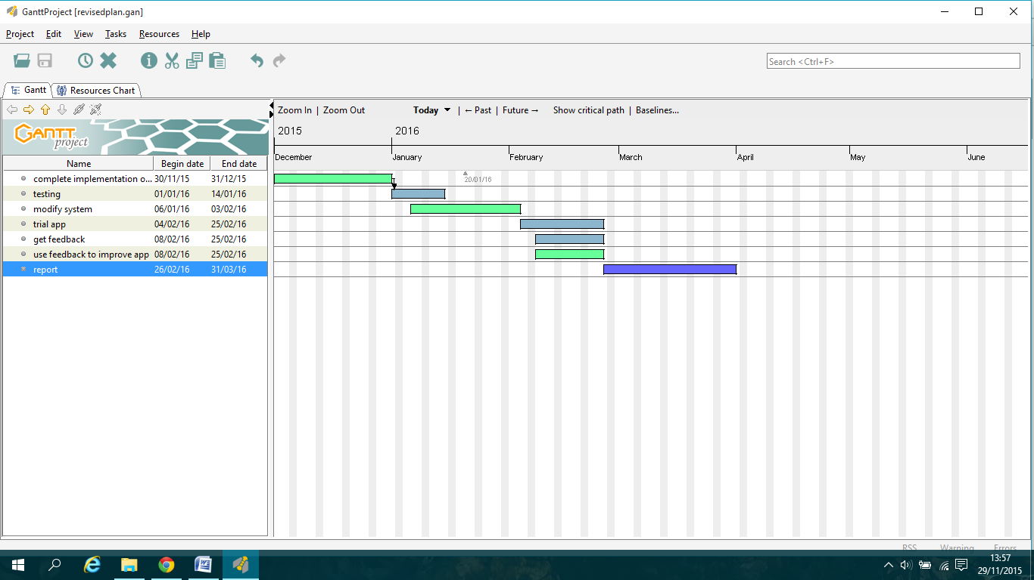**Revised work plan for Semester 2:**

This is my revised work plan for the rest of this semester and semester 2. I have changed some of the tasks from my original for example I have removed the task "connect database to system" as I have already set that up. Also I have brought forward the testing phase by a week as I believe that I am on track to finish a working version slightly earlier than anticipated. The rest is similar to my original with the start dates brought slightly forward. This will give me roughly 3-4 weeks before the deadline in April to make any other changes that I may need, and to use if I run into any problems (illness, major bugs etc).